**Customer Engagement Analysis with SQL and Tableau Project**

A Practical Approach to Analyzing and Visualizing Customer Engagement Metrics

**Case Description**

**Overview:** Our Customer Engagement Analysis with SQL and Tableau project offers an exceptional opportunity to enhance and expand your professional portfolio. Your task is to build a three-page dashboard including key metrics and visualizations that aims to show student engagement with the 365 platform and identify critical areas of improvement.

**Objective:** The following is a list of the questions we want our dashboard to answer:

* Which courses are the most watched by students, and how are they rated?
* How many students register each month, and what fraction are also onboarded?
* How do students engage with the platform (minutes and average minutes watched) based on student type (free-plan or paying)?
* Do students watch more content with time, and does it vary seasonally?
* Which countries have the most students registered, and does this number scale proportionally with the number of minutes watched per country?

Discuss your findings, uncover valuable insights, and gain meaningful experience working on a real-life database.

**Sketching the Dashboard**

Our Customer Engagement Analysis with SQL and Tableau project offers an exceptional opportunity to enhance and expand your professional portfolio. Your task is to build a three-page dashboard—including key metrics and visualizations that aim to show student engagement with the 365 platform and identify critical areas of improvement.

But how do we define engagement on the 365 platform? For this project, we’ll discuss engagement in the following way. Students are engaged on a particular day if they have watched a lecture. Using this definition, let’s introduce one more term: onboarding. Students are onboarded if they have watched a lecture on the 365 platform at least once.

Your goal is to have the following questions answered by the end of this project:

* Which courses are the most watched by students, and how are they rated?
* How many students register each month, and what fraction are onboarded?
* How do students engage with the platform (minutes and average minutes watched) based on student type (free-plan or paid)?
* Do students watch more content with time, and does it vary seasonally?
* Which countries have the most students registered, and does this number scale proportionally with the number of minutes watched per country?

In the dashboard_skeleton.pdf file, we’ve created a skeleton of the dashboard where you can locate the Charts, Tables, KPIs, and Parameters. For now, you’re only asked to get familiar with the structure of the dashboard. By the end of this project, you’ll have had it constructed in Tableau and then used it to answer the questions posed above.

**Part 2:** Retrieving Courses Information with SQL

1. Create a common table expression (CTE) named title_total_minutes that includes all records entering both the 365_course_info and 365_student_learning tables. Group the data by the course_id field to find the number of students and the total minutes watched per course.

WITH title_total_minutes AS

(

SELECT

course_id,

course_title,

ROUND(SUM(minutes_watched), 2) AS total_minutes_watched,

COUNT(DISTINCT student_id) AS num_students

FROM

365_course_info

JOIN

365_student_learning USING (course_id)

GROUP BY course_id

),

1. Create another sub-query named title_average_minutes that uses the last two fields from the title_total_minutes sub-query to calculate the average minutes watched per course.

title_average_minutes AS

(

SELECT

m.course_id,

m.course_title,

m.total_minutes_watched,

ROUND(m.total_minutes_watched/m.num_students, 2) AS average_minutes

FROM

title_total_minutes m

),

1. Create a third sub-query named title_ratings that left joins the title_average_minutes sub-query with the 365_course_ratings table. Calculate the number of ratings and the average rating per course. The left join ensures we retrieve courses from title_average_minutes that lack ratings and don’t have a corresponding record in the 365_course_ratings table.

title_minutes_averagemin_ratings AS

(

SELECT

a.*,

COUNT(course_rating) AS number_of_ratings,

IF(COUNT(course_rating) != 0, SUM(course_rating) / COUNT(course_rating), 0) AS average_rating

FROM

title_minutes_averagemin a

LEFT JOIN

365_course_ratings r USING (course_id)

GROUP BY course_id

)

1. Select all fields from the last CTE to get the desired result set.

SELECT

*

FROM

title_ratings;

**Part 3:** Retrieving Purchases Information with SQL

1. Start by using DROP VIEW IF EXISTS and CREATE VIEW followed by the name of the view—in this case, purchases_info.

DROP VIEW IF EXISTS purchases_info;

CREATE VIEW purchases_info AS

1. In the view, select the specific fields from the 365_student_purchases table. The date_start column is created by renaming the date_purchased column accordingly.

DROP VIEW IF EXISTS purchases_info;

CREATE VIEW purchases_info AS

SELECT

purchase_id,

student_id,

purchase_type,

date_purchased AS date_start

FROM

365_student_purchases;

1. Use a CASE statement to calculate the end date based on the purchase type. Each condition in the CASE statement corresponds to a different type of purchase (Monthly, Quarterly, Annual). The DATE_ADD function adds the appropriate number of months.

DROP VIEW IF EXISTS purchases_info;

CREATE VIEW purchases_info AS

SELECT

purchase_id,

student_id,

purchase_type,

date_purchased AS date_start,

CASE

WHEN

purchase_type = 'Monthly'

THEN

DATE_ADD(MAKEDATE(YEAR(date_purchased),

DAY(date_purchased)),

INTERVAL MONTH(date_purchased) MONTH)

WHEN

purchase_type = 'Quarterly'

THEN

DATE_ADD(MAKEDATE(YEAR(date_purchased),

DAY(date_purchased)),

INTERVAL MONTH(date_purchased) + 2 MONTH)

WHEN

purchase_type = 'Annual'

THEN

DATE_ADD(MAKEDATE(YEAR(date_purchased),

DAY(date_purchased)),

INTERVAL MONTH(date_purchased) + 11 MONTH)

END AS date_end

FROM

365_student_purchases;

**Part 4:** Retrieving Students Information with SQL

1. Use LEFT JOIN to create a query that joins the 365_student_info and the 365_student_learning tables such that you are sure to retrieve all records from the first table. Select all columns from 365_student_info and the date_watched column from 365_student_learning. Note that the date_watched column can be NULL if a student from the 365_student_info hasn’t watched any lectures.

SELECT

i.*,

l.date_watched

FROM

365_student_info i

LEFT JOIN

365_student_learning l USING(student_id)

1. Create a column called minutes_watched to calculate the sum of all minutes watched by a single student on a day and round the resulting sum to two decimal places. Note that you need to check if a student hasn’t watched any lectures—i.e., they don’t have any record in the 365_student_learning table. If so, their sum of watched minutes should be set to 0.

SELECT

i.*,

l.date_watched,

IF(l.student_id IS NULL, 0, ROUND(SUM(l.minutes_watched), 2)) AS minutes_watched

FROM

365_student_info i

LEFT JOIN

365_student_learning l USING(student_id)

GROUP BY student_id , date_watched

1. Create another column called onboarded**,** evaluated at 0 if a student has no record in the 365_student_learning table. They are onboarded if they have watched a lecture, indicated with a 1in the column.

SELECT

i.*,

l.date_watched,

IF(l.student_id IS NULL, 0, ROUND(SUM(l.minutes_watched), 2)) AS minutes_watched,

IF(l.student_id IS NULL, 0, 1) AS onboarded

FROM

365_student_info i

LEFT JOIN

365_student_learning l USING(student_id)

GROUP BY student_id , date_watched

1. Use the query you derived as a subquery and alias it as a. Join it with the purchases_info view using a LEFT JOIN so that all records from a are retrieved. Select all columns from a. Create a new column (call it paid), which is evaluated at 1 if a lecture is watched between the subscription’s start date and the same subscription’s end date. Otherwise, set it at 0.

SELECT

a.*,

IF(date_watched BETWEEN p.date_start AND p.date_end, 1, 0) AS paid

FROM

( -- First sub-query

) a

LEFT JOIN

purchases_info p USING (student_id)

Note that the case where the date_watched column is NULL—indicating a student hasn’t watched any lectures—is also covered by this second condition, and the paid column would be evaluated at 0.

1. Use the query created at step 4 as a new subquery; call it b. Select the first six columns from b. Then, select the maximum value of the paid column for a single student_id – date_watched pair.

SELECT

student_id,

student_country,

date_registered,

date_watched,

minutes_watched,

onboarded,

MAX(paid) AS paid

FROM

( -- Second sub-query

) b

GROUP BY student_id , date_watched;

Why is this necessary? Multiple rows can be present in subquery b for a specific student–date combination due to multiple subscriptions recorded. Each row represents a different subscription with a different paid value. To determine the overall paid status for a student on a particular date, we need to consider the maximum value of the paid column. This would determine if a student was a paid member on the date specified by the date_watched column.

**Interpreting the Results**

The dashboard turned out great! You’re now at the final and critical task of analyzing the results. Please return to the questions we posed at the beginning of the project. Using the dashboard you created, how would you answer each of them, and what conclusions can you draw?

1. Which courses are the most watched by students, and how are they rated?  
   **Hint:***Use the table you created in Tableau to answer this question.*
2. How many students register each month, and what fraction are also onboarded?  
   **Hint:***Use the Registered Students’ and Onboarded Students’ KPIs and the stacked bar chart you created in Tableau to answer this question.*
3. How do students engage with the platform (minutes and average minutes watched) based on student type (free-plan or paying)?  
   **Hint:***Use the Minutes Watched and Average Minutes Watched KPIs you created in Tableau to answer this question.*
4. Do students watch more content with time, and does it vary seasonally?  
   **Hint:***Use the combo chart you created in Tableau to answer this question.*
5. Which countries have the most students registered, and does this number scale proportionally with the number of minutes watched per country?  
   **Hint:***Use the funnels you created in Tableau to answer this question.*
6. *Which courses are the most watched by students, and how are they rated?*

Let’s begin by answering this first question using the table you created.

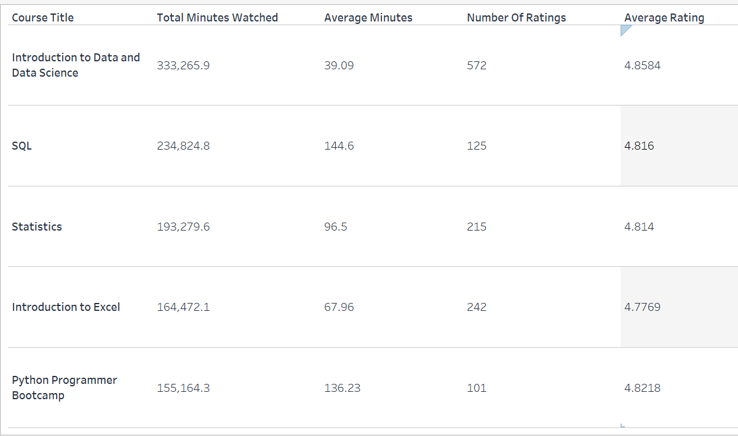

Based on the table, the course that is most watched by students in terms of total minutes is Introduction to Data and Data Science, with a total of 333,265.9 minutes. This is unsurprising because this course serves as a stepping stone for the rest of the courses on the platform and is the apparent choice when embarking on a data science journey. It’s worth noting that this course is on the shorter side, with nearly two hours of content. This observation—together with the high number of ratings the course has received—is even more suggestive of its importance.

But when considering the ‘average minutes watched’ metric, the course that seems to engage students for the most prolonged period is SQL, with an average of 144.6 minutes per student. Indeed, this is another of the more popular courses on the 365 platform because SQL is essential when aiming for a data scientist or a data analyst career. We should mention, of course, that the high value of the average minutes watched can also be owed to the fact that SQL and Python Programmer Bootcamp are two of the most extended courses on the platform at roughly 8 and 11 hours, respectively.

Statistics, Introduction to Excel, and Python Programmer Bootcamp are the other three courses with the highest watching rate.

The ratings of all five courses are roughly 4.8, which is an excellent result, given the high number of ratings.

1. *How many students register each month, and what fraction are also onboarded?*

Let’s answer the question above by using the Registered Students’ and Onboarded Students’ KPIs and the stacked bar chart you created.

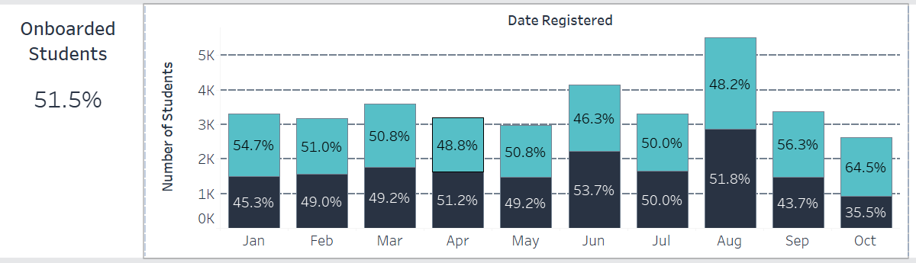

The Registered Students’ KPI shows 35,230 students registered on the platform for the entire period of the analysis. The Onboarding Students’ KPI shows an onboarding rate of more than 50%, which is an excellent result. It suggests that half of the registered students also watch a lecture on the platform.

We should not forget the question: Why have half of the students registered on the platform not watched a lecture? Could it be because they encountered user experience problems, couldn’t find anything interesting, or didn’t know where to start? Resolving these inquiries can be achieved through the following:

* + Testing the platform for possible issues
  + Adding more relevant content or reaching out to people who will find the current content interesting and valuable
  + Improving the users’ journey and guiding them toward a learning path

As for the monthly onboarding rate drawn from the stacked bar chart (the upper part displays the fraction of onboarded students), we can see that it fluctuates between 46% and 64%, with the latter number corresponding to October and slightly higher than the rest of the months possibly because we’re not considering the last 11 days of October in this analysis.

1. *How do students engage with the platform (minutes and average minutes watched) based on student type (free or paid)?*

Let’s use the rest of the KPIs to answer this question. Considering the entire analysis period (January 1, 2022 – October 20, 2022), the total minutes watched by free-plan students is roughly 491,000 minutes, while the ones watched by paying students are about 1,345,000.

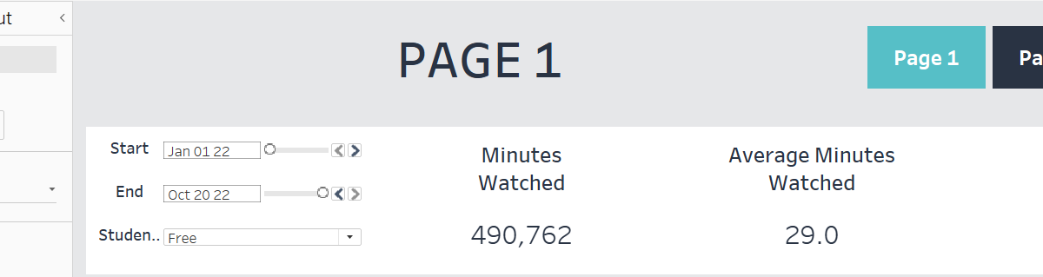

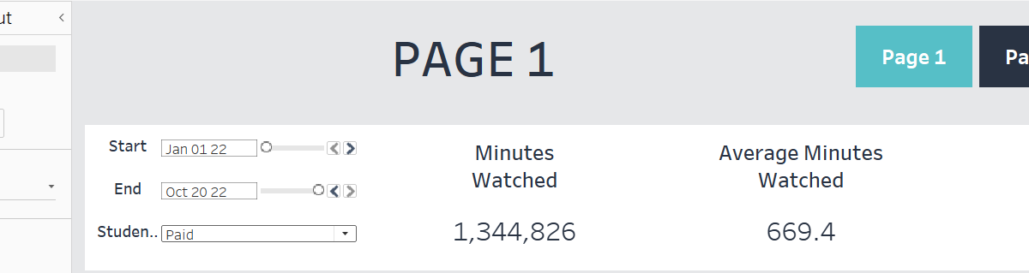

We observe a significant difference in the results. Free-plan students are typically less motivated to study and less dedicated to the platform. The content unlocked to free-plan students is limited—roughly 30 minutes per course. On the other hand, paying students look for more value for their investment, are more likely to study persistently, and take full advantage of the platform once it’s unlocked.

The difference in average minutes watched by free-plan and paying students is also non-negligible. While the former type of student watches roughly 29 minutes on average, the latter watches about 670 minutes. If you adjust the parameters to cover only the middle days of August, the average minutes watched by free-plan students jumps to about 70 minutes.

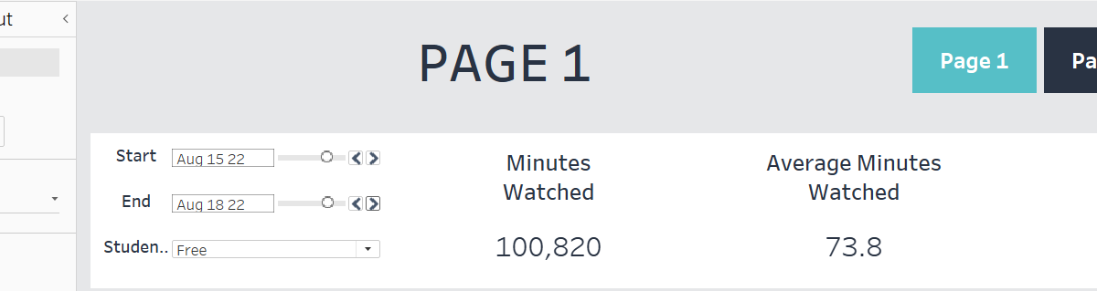

The reason is that in August, the 365 team opened their platform free of charge for all its students. This has increased the engagement, as we’ll see now while discussing the combo chart.

1. *Do students watch more content with time, and does it vary seasonally?*

We can turn to the combo chart for an answer to this question. We notice a prominent peak in the minutes watched in August by free-plan students—a result of the Free-Days campaign the 365 marketing team ran.

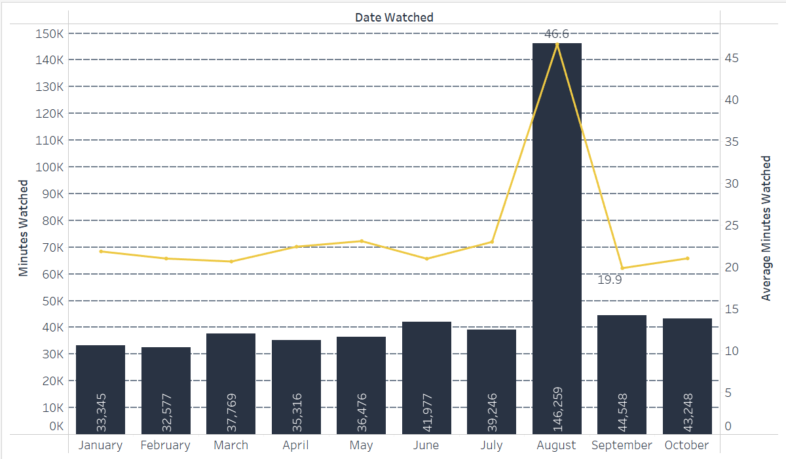

We observe that the same is not valid for the paying student. This makes sense since they already have full access to the product and are not affected by the campaign in the same way.

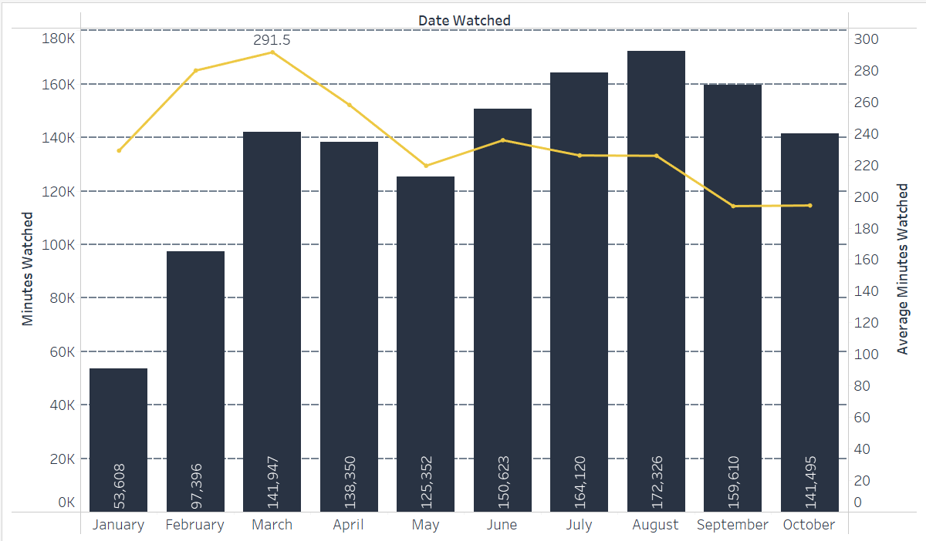

Overall, however, we observe a slight increase in the (average) minutes watched by free-plan students, a fluctuating tendency in the minutes watched by paying students, and a slightly decreasing trend in the average minutes watched by paying students.

1. *Which countries have the most students registered, and does this number scale proportionally with the number of minutes watched per country?*

By removing the Registration Date Filter from the Filters shelf temporarily, we can study the two funnel charts for students registered between January 1, 2022, and October 20, 2022 (the entire period of the analysis). It’s interesting to make this analysis for free-plan and paying students separately. For free-plan students, most registered on the platform and watching courses come from India.

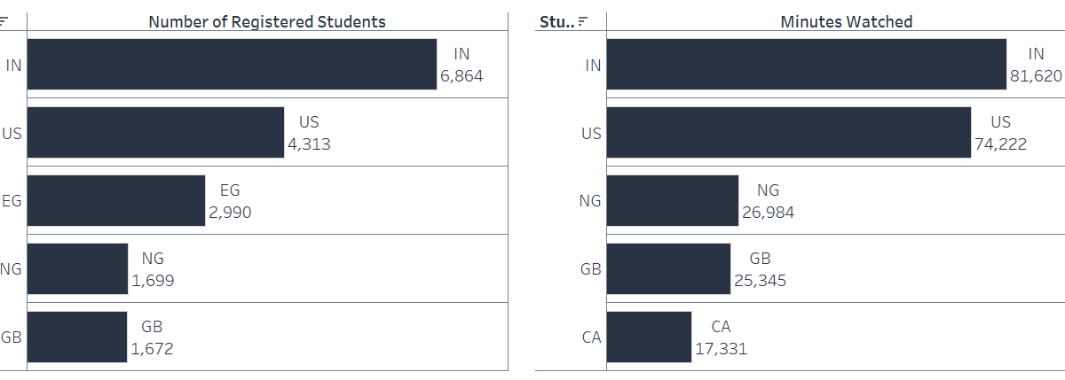

For paying students, on the other hand, it’s those from the US that lead both metrics. We also observe higher traffic from people from Egypt, Nigeria, the UK, Canada, and India. However, both funnel charts suggest that the number of registered students per country doesn’t always scale proportionally with the number of minutes watched.

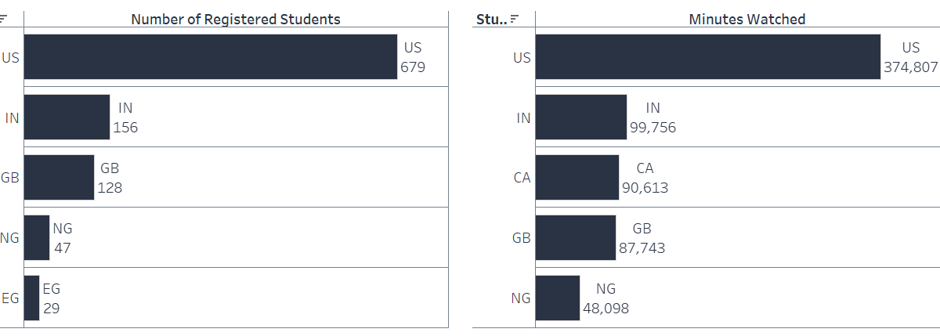

Conduct a similar analysis, this time using the Registration Month filter, and observe the changes over time.

Now that you are familiar with the business case and the database, feel free to retrieve more information using SQL and create more visualizations that will bring value to the dashboard and answer more business questions.